Prof. Tahira Zafar,Director Haemophilia Treatment center (HTC) shares her experience of developing haemophilia care in Rawalpindi with Paediatric Oncology in Developing Countries (PODC) &
Children Cancer & Lymphoma Group (CCLG) virtual meeting on
11th Feb 2021

The haemophilia journey started after a chance encounter with a patient of Haemophilia , listening to his lifelong misery & suffering o & realizing that the absence of appropriate medical treatment caused immense problems, both emotional and financial, for haemophilic patients and their families & deciding to work to improve their care.
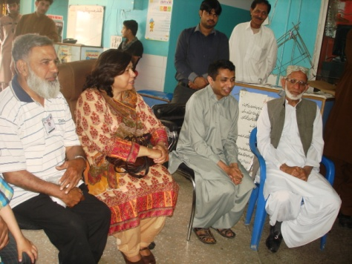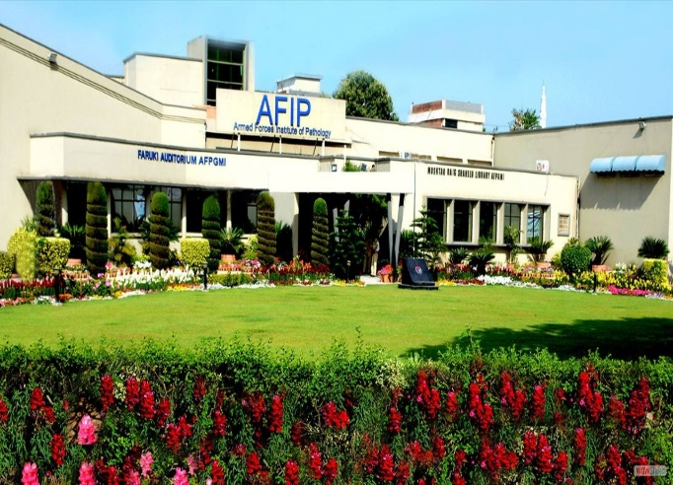
The first Challenge! AFIP, the first Haemophilia Clinic
A small clinic was established in haematology dept. of AFIP in the early nineties. As word got round patients started coming from everywhere, overwhelming the system. This led to a group of Haemophilia care physicians ,patients, parents & volunteers to form a haemophilia Society ,Haemophilia patients welfare Society Rawalpindi (HPWS Rwp) in 1999 ,with its own Haemophilia Treatment Center( HTC) &joining hands with a network of hospitals(Haemophilia Friendly Hospitals ,Holy Family , Benazir Bhutto & Children hospital ) & Haemophila Care Givers(Medical Advisory Board) which included specialties like haematology, orthopaedics ,physiotherapy, dentistry, gynae & obstetrics . The Society & the HTC moved into a bigger office (809 D Satellite Town). Links were developed with local institutions, Armed Forces Institute of Pathology (AFIP) , Armed Forces Institute of Transfusion (AFIT),Pakistan Institute of Medical Sciences(PIMS), National Institute of Health (NIH).
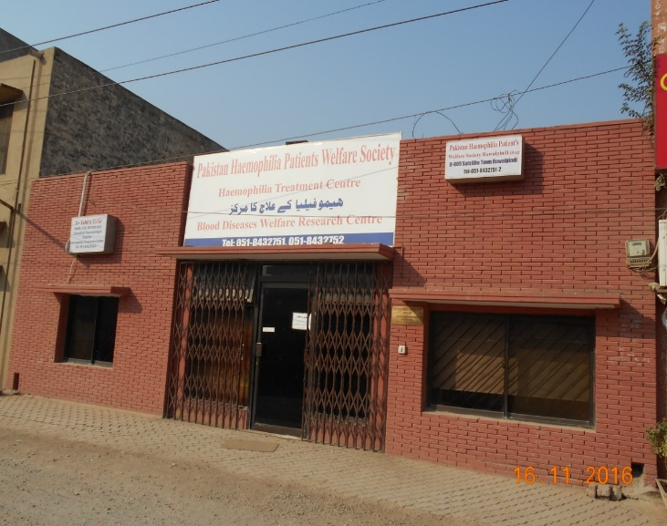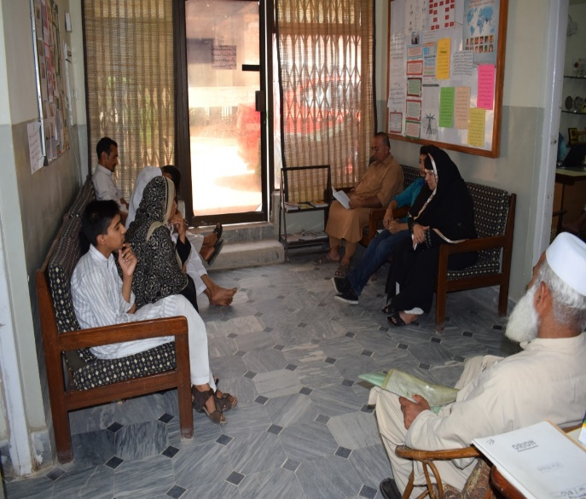
Haemophilia Society office & Treatment Center
Development of a Haemophilia Center at Children Hospital PIMS covered the inpatient requirements & development of a strong team which included a rehab medicine consultant and a paediatric dentist.

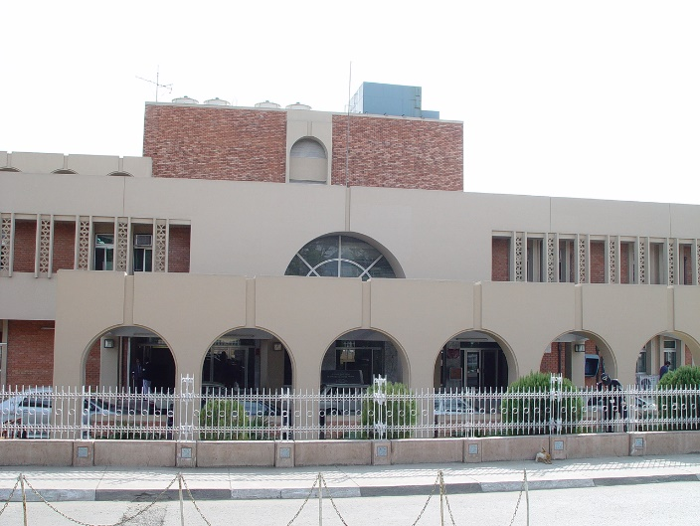
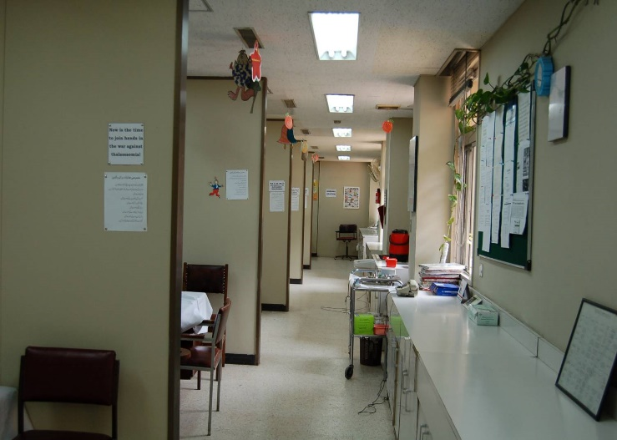
Haemophilia Treatment Center , Children Hospital ,PIMS
It was realized at this stage that it was important to create awareness & educate patients & their families about haemophilia .With support from Novo Nordisk Haemophilia Foundation, literature was developed in Urdu & workshops were conducted to improve knowledge about haemophilia.
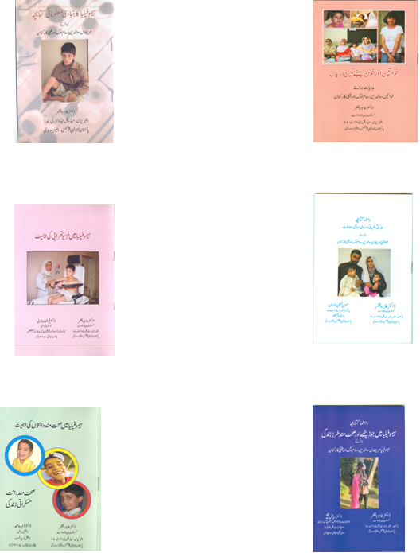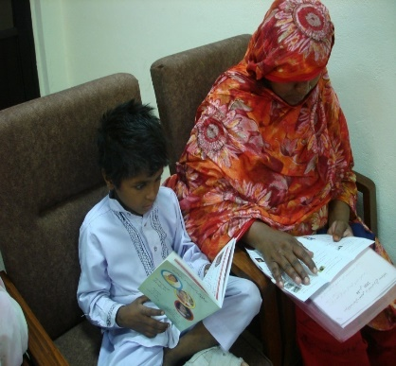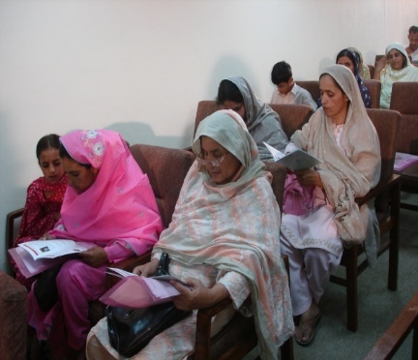
Haemophilia literature in Urdu Education & awareness workshops

In 2000 HPWS Rwp and other haemophilia societies in Karachi & Lahore joined the World Federation of Haemophilia(WFH) as the National Member Organization(NMO).The development of organizational & HTC twinnings ( Haemophilia Society Malaysia & Kent Haemophilia Center ,Canterbury) led to exchange of knowledge & practice and enormous growth which continues to date in the form of educational workshops, fellowships, development grant Program ( DGP ) and donations of concentrates through it Humanitarian Aid Program (HAP).
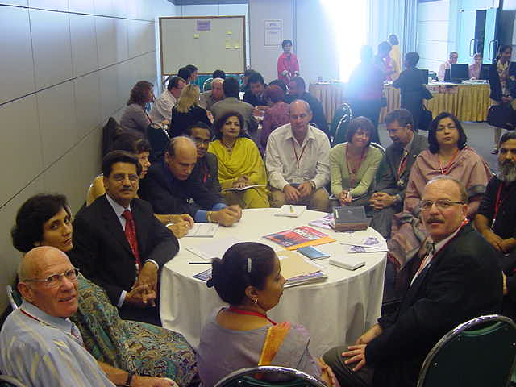
WFH Collaboration
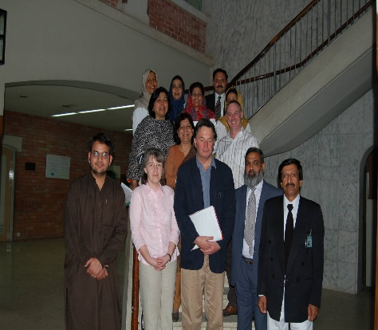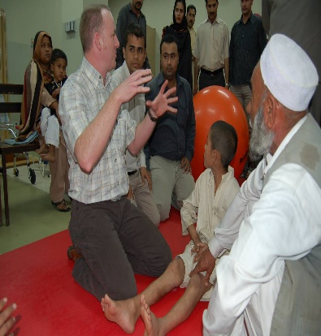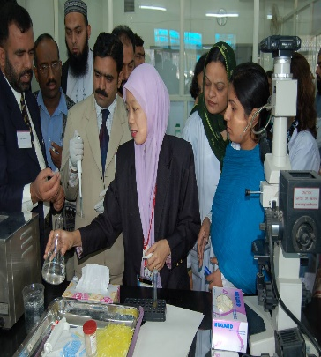
WFH twinning & Training
Save One Life (SOL) program has also helped in improving quality of life of our patients. 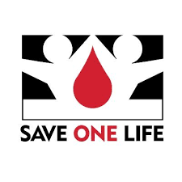 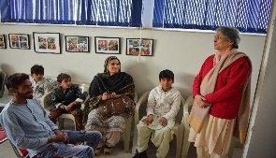
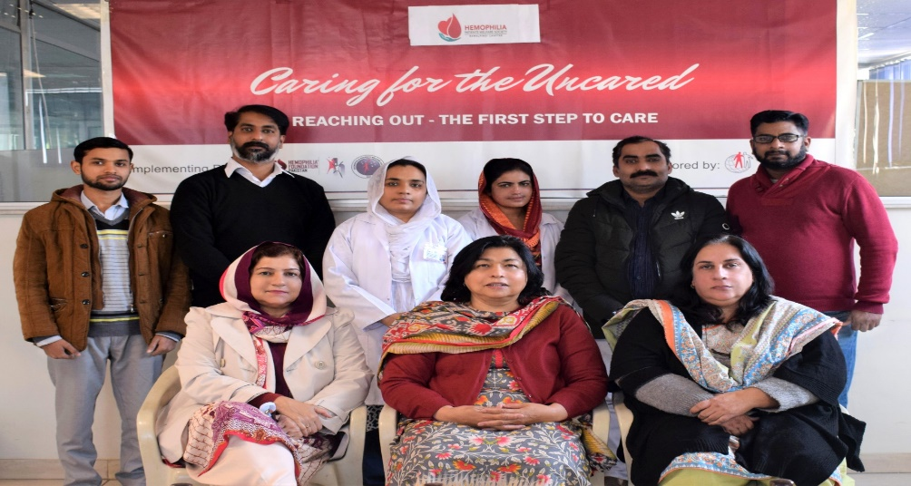
Our staff Working hard to make a difference
Presently, HPWS Rwp with its local & international links ,caters to the needs of around 1200 patients with inherited bleeding disorders

