The Global Summit on Women and girls with inherited bleeding has shifted the attention and focus to where it is most needed .It has not only provided an important recognition of the effect that bleeding disorders have on women & girls but also allowed the bleeding disorder community to come together, in a collective effort, to address issues of care & treatment relating to them & the global work being done to improve their lives.

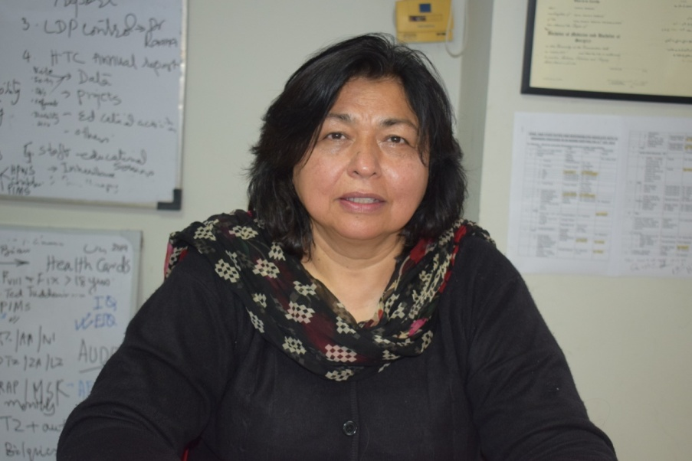

Dr Tahira Zafar , in the session on , Stigmatization and breaking through the 'norms, addressed the barriers women and girls with an inherited bleeding disorder confront due to cultural norms, taboos and stigmata associated with their condition in Pakistan .
The major related issues are suffering due to delay in diagnosis & non availability of treatment ,Emotional strain due to financial burden on the family, keeping the disease a secret for fear of rejection & inability to make major decisions in their lives like education ,work ,marriage etc. Problems with reproductive health adds additional pressure.
These have been dealt by awareness & education ,communication, speaking out,& networking with helpful care givers. The knowledge about the disease & understanding its impact on their lives has helped these women & girls develop a positive attitude to life . This has also created awareness in their families who are more supportive as they understand their suffering.
All this will hopefully ease the burden & suffering of these girls of today & help them develop them into confident young women of tomorrow .

