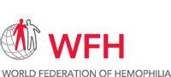

**World Federation of Hemophilia (WFH) Virtual Summit,14th to 19th  June 2020, a great event to bring the global bleeding disorder community together**

**The Haemophilia Care Physicians (HCP’s) at Haemophilia Treatment Centre (HTC) of HPWS Rawalpindi, participate actively in the World Federation of Hemophilia (WFH) virtual Summit**

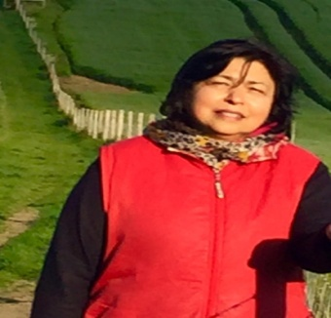 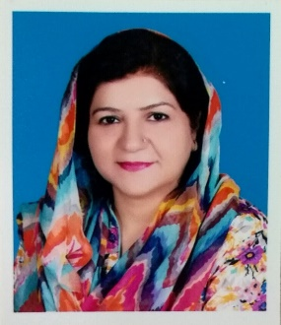 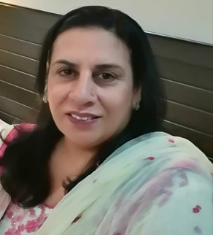 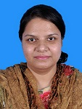 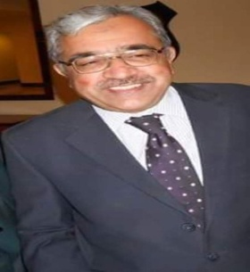

Prof. Tahira Zafar Prof. Lubna Zafar Dr Bilquis Sohail Dr Raana Zeeshan Dr Nadeem Ikram

Director HTC D/ Director HTC MO Incharge HTC Consultant HTC Consultant HTC

The WFH Congress was scheduled for 16th to 19th June in Kuala Lumpur, Malaysia. In view of COVID 19 crisis the WFH brought the bleeding disorder community together virtually in the form of WFH Virtual Summit. This included a series of FREE live and recorded sessions which took place from June 14 to 19, 2020 and allowed the bleeding disorders community, both patients & haemophilia care professionals (HCP’S), to increase their knowledge from where ever they were in the world.

The HCP”s at the HTC contributed significantly to the summit by participating in Virtual bed side rounds (2 case presentations), 3 poster presentations and 2 oral presentations.

**Virtual bed side rounds**

* **A young female with Factor V deficiency & massive GI bleeding** was discussed by Prof. Lubna Zafar.
* **Case of 16 year old boy with Severe haemophilia A & spontaneous Loss of wrist movements over 2 years with hand fixed in extension & radial deviation** was presented by Prof. Tahira Zafar

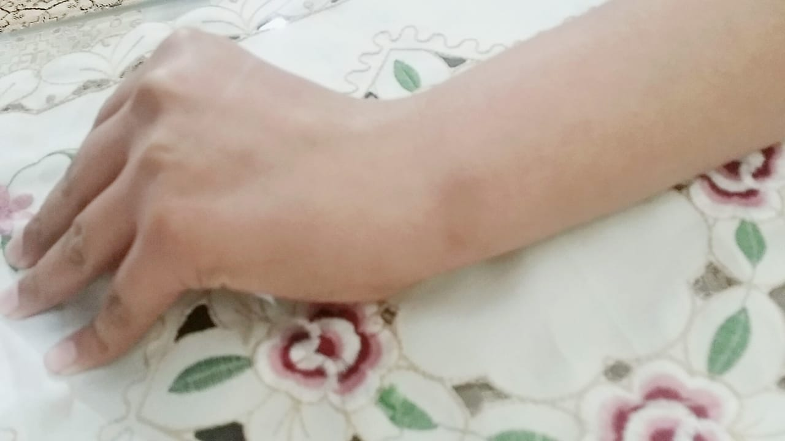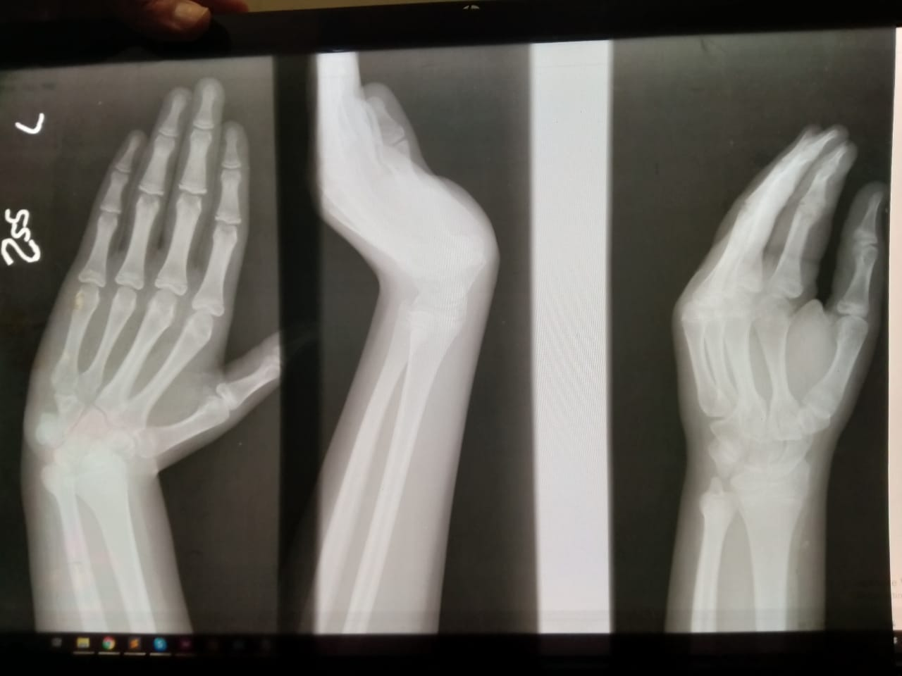

**Poster Presentations**

* **Impact of low dose prophylaxis on spontaneous bleeding episodes in patients with haemophilia A in a developing country**

Zafar T1, 2, Zafar L1, 3, Sohail B1

HTC, HPWS Rawalpindi1, Frontier Medical College,

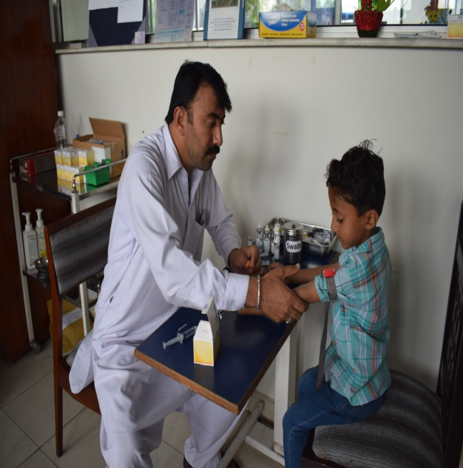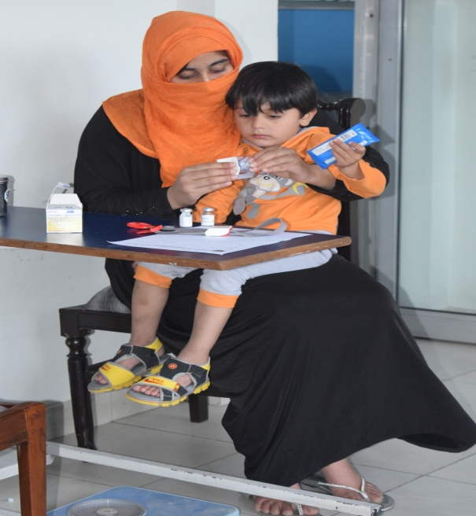

**Getting ready to receive the FVIII infusion Mother’s help with Factor preparation**

* **WBDR abstract series: Real World Data from around the World**

**WFH World Bleeding Disorders Registry Challenges & Achievements: a**

**Single HTC experience**

Zafar T1, 2, Zafar L1, 3, Sohail B1

HTC, HPWS Rawalpindi1, Frontier Medical College,

* **Efficacy of low dose prophylaxis vs. on demand treatment in severe Haemophilia A children: a case control study**

**Zees anR 1,2, Zafar T 1,3, Zafar L 1,4, Ikram N1,2**

HTC , HPWS Rawalpindi 1, Benazir Bhutto Hospital, Rawalpindi 2, Frontier Medical College , Abbotabad , Pakistan**3 ,**Foundation University Medical College ,Islamabad4

**Oral Presentations**

Prof. Lubna Zafar talked about **The Menace of Menorrhagia in Females with Inherited Bleeding Disorders in Pakistan**

The talk covered pattern of clinical presentation of bleeding in females affected with inherited bleeding disorders registered with HTC, HPWS Rawalpindi. Out of the 90 patients included in the study, 45 were of von Willebrand type 3 & 34 that of Glanzmann’s Thrombasthenia.

Menorrhagia was the commonest symptom followed by mucocutaneous bleeding in females with bleeding disorders and had a huge impact on the lives of females including anemia ,anxiety, absence from school /dropout, social isolation ,not getting married due to taboo, marital problems, difficulty in conceiving, Excessive bleeding during childbirth and purperium & concerns about the child having bleeding disorder

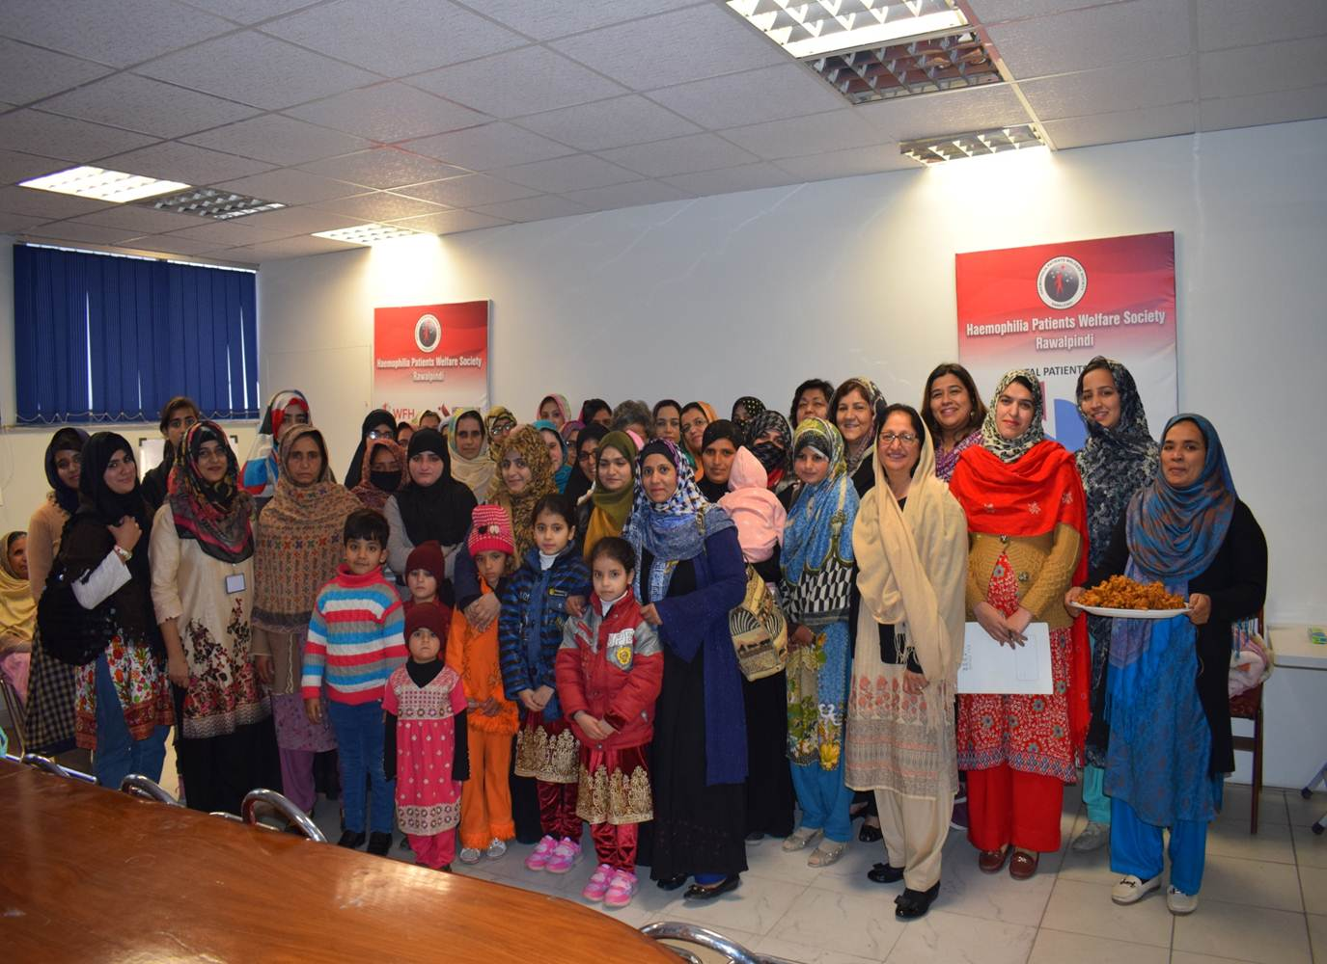

Prof. Tahira Zafar was an invited speaker on the session**, Impact of challenges of bleeding disorders in women and girls** and talked about**, Diagnostic dilemma and approach to women and girls in a Developing country.**

The presentation highlighted the many challenges women face in Pakistan which are:

* Women are not free to decide for themselves & do not speak up about their health issues causing a delay in the diagnosis
* ,Lack of awareness on the part of the treating physician GP/ Gynaecologist requiring multiple visits before a diagnosis is made
* Delay in diagnosis and failure to get proper treatment, causes an irreparable damage to patients well being. It can at times have fatal consequences
* Failure to investigate the women with inherited bleeding disorders limit the potential benefits of different therapies like, tranexmic acid, FFP and cryoprecipitate & factor concentrates
* Difficulties in getting diagnosed patients married. Many of the parents who make the marriage decisions decide against it due to the problems with bleeding issues later on which they will have to deal with ,as is customary in the society
* At times the diagnosis is kept a secret due to rejection. When it comes to light later on it causes a lot of pressure for the woman & can lead on to separation & divorce**.**

To resolve these issues it is important to create **awareness that Women bleed too!** This has to be done at all levels including **patients, their families, health care professionals & general public.**

**Awareness was raised by programs on television, awareness workshops for patients & health care professionals**

**Television awareness programs**

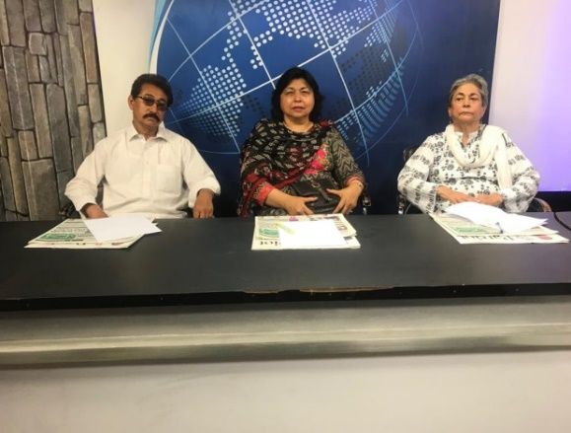 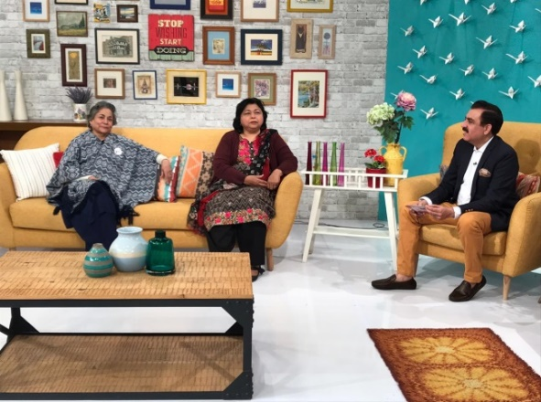

**Health care professional’s educational sessions**

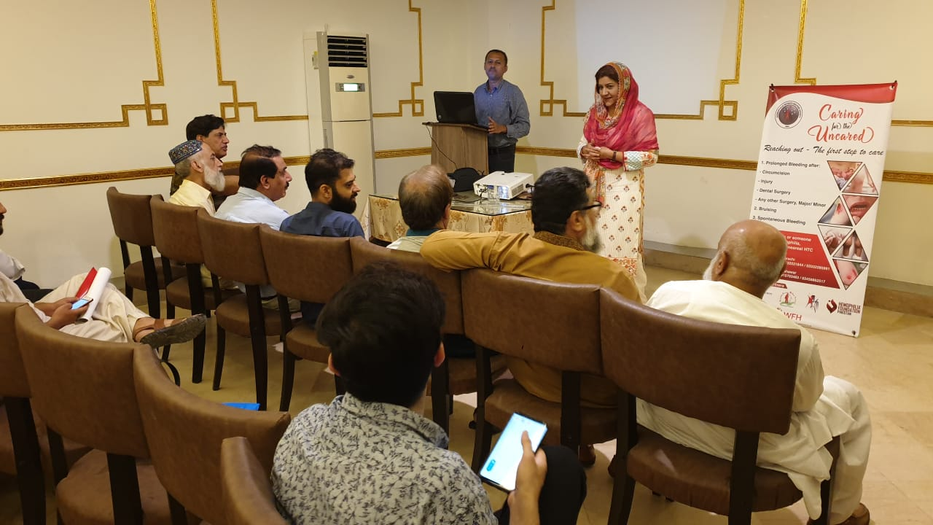 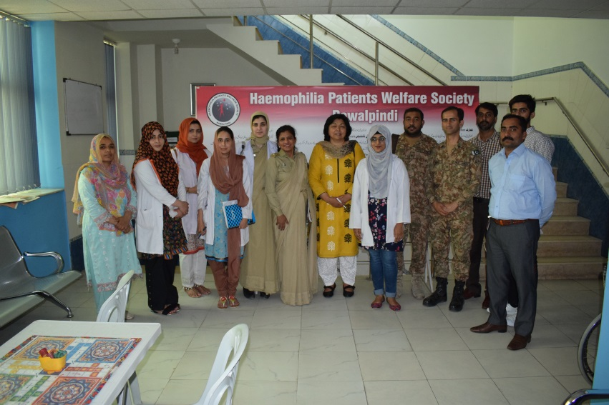

**Patient’s awareness workshop**

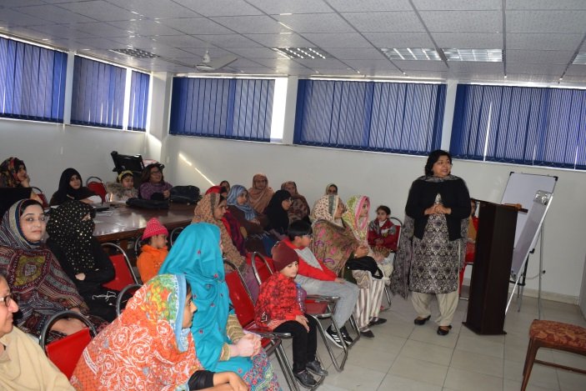

**The activities of the HTC were highly appreciated by the organizers of the WFH Virtual Summit**