Report on World Hemophilia Day
World Hemophilia Day is celebrated each year on April 17 to express solidarity with hemophilic community and to make them feel integrated in the society. Moreover, it also serves the purpose of creating awareness among general masses about this rare bleeding disorder. Like every year PHPWS R/I Chapter celebrated WHD with great zeal and enthusiasm this year as well. However, the events organized for this day were quite innovative in their essence because of the pandemic of Covid-19. Though there was ban on congregation, hemophilic community did not miss the event. Rather they employed the online platform in the best manner to make the day memorable.
An online drawing competition was held for the patients and young patients made beautiful drawings and posters to express their feelings. Furthermore, prizes were arranged for the best sketches, which will be distributed after the final announcement of the result. A glimpse of these colorful drawings takes the reader into their innocent and hemophilic world.
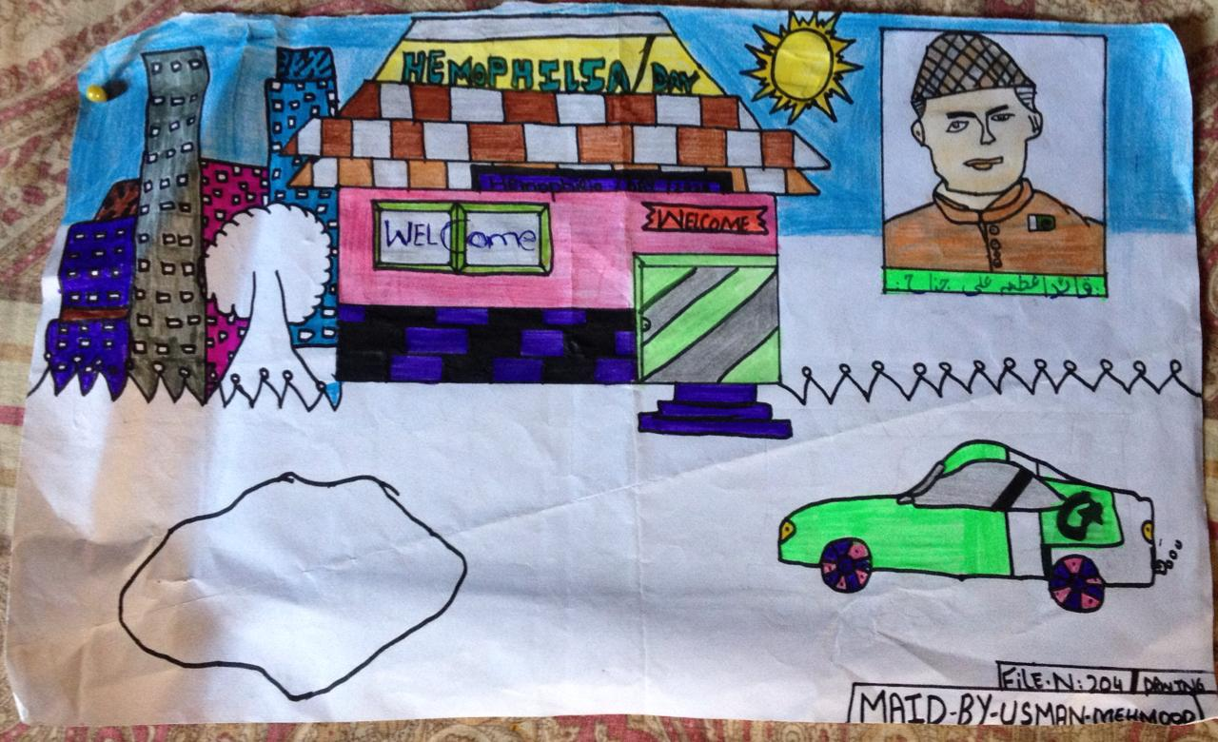
In addition to young, adult patients did not lag behind and they also made the productive use of quarantine time and sent their amazing life stories to get other patients inspired and face this challenge whole heartedly. Different patients who rendered voice to their feelings are Abira, Ali Raza, Ayesha, Maryam and many others.
Another important event of this day was SOL (Save One Life) distribution. SOL scholarships help patients in numerous field such as education, business etc. They make them stand on their feet and not to become a burden on parents or society. The importance of SOL scholarship was also expressed by a young patient in beautiful words.
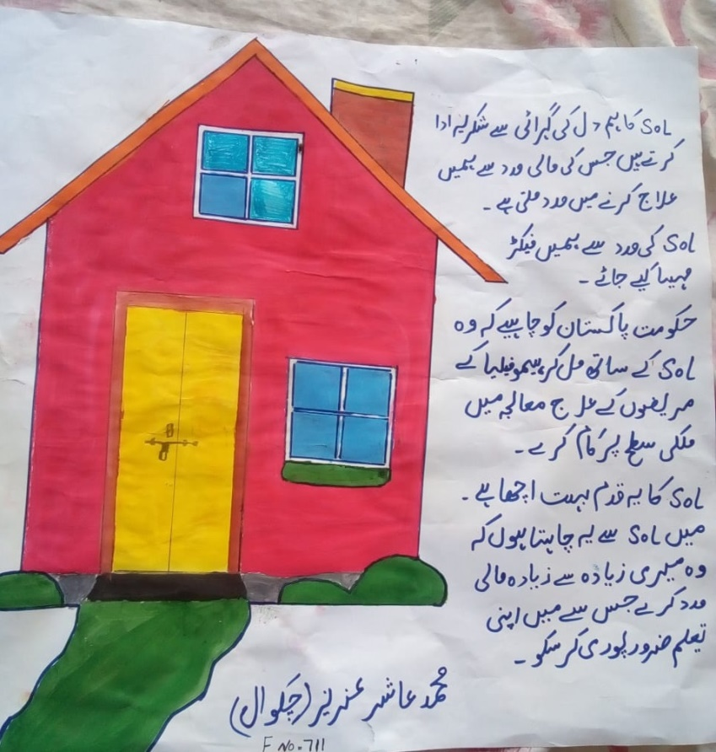
Other than patients, doctors and staff also participated fully in the event and added colors to it. They are the source of constant support and they make patients to view life with lens of optimism and courage. Their continuous availability deserves to be acknowledged on this important event.
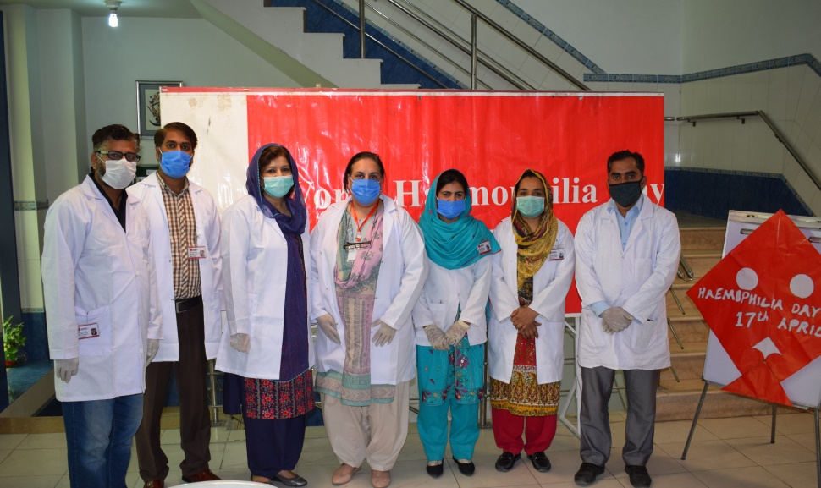
Doctors also employed the platform of electronic media to spread awareness and make the voice of hemophilic community to be heard across the whole world. Conclusively, it was a memorable day and was not eclipsed by the pandemic of Covid-19.

